##### SYMBIOTE: Theft Detection

***An image detecting tool using ML…….***

**A PROJECT REPORT**

###### ***Submitted by***

1. Parmeet Singh Banwait (20BAI10141)
2. MVN Rajesh Reddy (20BAI10249)
3. Sparsh Handa (20BAI10295)
4. Mohd Mohsin Khan (20BAI10340)

*in partial fulfillment for the award of the degree*

*of*

##### BACHELOR OF TECHNOLOGY

*in*

**PROGRAM OF STUDY**



**SCHOOL OF COMPUTING SCIENCE AND ENGINEERING**

**VIT BHOPAL UNIVERSITY**

**KOTHRI KALAN, SEHORE**

**MADHYA PRADESH - 466114**

December, 2021

**VIT BHOPAL UNIVERSITY, KOTHRI KALAN, SEHORE**

**MADHYA PRADESH – 466114**

**BONAFIDE CERTIFICATE**

Certified that this project report titled **SYMBIOTE: Theft Detection** is the bonafide work of Parmeet Singh Banwait(20BAI10141), MVN Rajesh Reddy (20BAI10249), Sparsh Handa (20BAI10295) and Mohd Mohsin Khan (20BAI10340) who carried out the project work under my supervision. Certified further that to the best of my knowledge the work reported at this time does not form part of any other project/research work based on which a degree or award was conferred on an earlier occasion on this or any other candidate.

**PROGRAM CHAIR PROJECT GUIDE**

Dr S Southarajan Mr SSP Shukla

School of Computer Science and Engineering School of Computer Science and Engineering

VIT BHOPAL UNIVERSITY VIT BHOPAL UNIVERSITY

The Project Exhibition I Examination is held on _______________

**ACKNOWLEDGEMENT**

First and foremost I would like to thank the Lord Almighty for his presence and immense blessings throughout the project work.

I wish to express my heartfelt gratitude to Dr S Southarajan, Head of the Department, School of Computer Science for much of his valuable support and encouragement in carrying out this work.

I would like to thank my internal guide Mr Kailash, for continually guiding and actively participating in my project, giving valuable suggestions to complete the project work.

I would like to thank all the technical and teaching staff of the School of Computer Science and Engineering, who extended directly or indirectly all support.

Last, but not least, I am deeply indebted to my parents who have been the greatest support while I worked day and night for the project to make it a success.

**LIST OF ABBREVIATIONS**

| **S.No** | **Abbreviation** | **Used For** |
| --- | --- | --- |
| 1 | Fig | Figure |
| 2 | Img | Image |
| 3 | Imgs | Images |
| 4 | ML | Machine learning |
| 5 | SSD | Single Shot Detection |
| 6 | R-CNN | Regions with convolutional neural networks |
| 7 | CCTV | Closed-Circuit Television |
| 8 | GUI | Graphical User Interface |

**LIST OF FIGURES AND GRAPHS**

| **FIGURE NO.** | **TITLE** | **PAGE NO.** |
| --- | --- | --- |
| 1 | SSD Layers | 12 |
| 2 | Detection | 13 |
| 3 | Object Detection Algorithm | 15 |
| 4,5,6 | Car Detected | 17 |
| 7 | SSD Stages | 18 |
| 8 | Present Architecture Diagram | 24 |
| 9 | Future Implementation- Architecture Diagram | 24 |
| 10 | Outline of Chapter 5 | 26 |
| 11 | Training Data ScreenShot | 29 |
| 12 | LabelImg | 30 |
| 13 | Training Model Output | 30 |
| 14, 15, 16, 17, 18 | Output of the model | 34, 35 |

**LIST OF TABLES**

| **TABLE NO.** | **TITLE** | **PAGE NO.** |
| --- | --- | --- |

(no tables are included in the report)

**ABSTRACT**

The abstract of our application is about Object Detection. Our application name is SYMBIOTE, which actually is divided into two parts, the first which compares the dataset and another which actually is the user interactive and performs the task given by the user.

Symbiote- An object detection tool using SSD Module, is a computer technology related to computer vision and img processing that deals with detecting instances of semantic objects of a certain class in digital imgs and videos. What makes us different is that in the same application we are using the same algorithm that can detect imgs and some features in general. We are using an SSD module to actually detect them. An SSD is a single-shot detector. It has no delegated region proposal network and predicts the boundary boxes and the classes directly from feature maps in one single pass. SSD uses a matching phase while training, to match the appropriate anchor box with the bounding boxes of each ground truth object within an img. We have designed it in a way, so that it can detect what a user wants to detect. For example- If a car is stolen and a user needs to detect its car, he or she can give the details of the car and the model will give the relevant data which are the same as that the user is looking for. We have a keen vision that it can be used as a theft-detecting model in the future, with some sort of modifications in it.

**[PURPOSE-METHODOLOGY-FINDINGS]**

**TABLE OF CONTENTS**

| **CHAPTER NO.** | **TITLE** | **PAGE NO.** |
| --- | --- | --- |
|  | List of Abbreviations  List of Figures and Graphs  List of Tables  Abstract | **3**  4  5  6 |
| 1 | **CHAPTER-1: PROJECT DESCRIPTION AND OUTLINE** Introduction 1.2 Motivation for the work  1.5 Problem Statement  1.6 Objective of the work  1.7 Organization of the project  1.8 Summary | 11  .  .  . |
| 2 | **CHAPTER-2: RELATED WORK INVESTIGATION**  2.1 Introduction  2.2 Core area of the project  2.3 Existing Approaches/Methods  2.3.1 Approaches/Methods -1  2.3.2 Approaches/Methods -2  2.3.3 Approaches/Methods -3  2.4 <Pros and cons of the stated Approaches/Methods >  2.5 Issues/observations from investigation  2.6 Summary | 13 |
| 3 | **CHAPTER-3: REQUIREMENT ARTIFACTS**  3.1 Introduction  3.2 Hardware and Software requirements  3.3 Specific Project requirements  3.3.1 Data requirement  3.3.2 Functions requirement  3.3.3 Performance and security requirement  3.3.4 Look and Feel Requirements  3.4 Summary | 18 |
| 4 | **CHAPTER-4: DESIGN METHODOLOGY AND ITS NOVELTY**  4.1 Methodology and goal  4.2 Software Architectural designs  4.3 Subsystem services  4.4 Novelty  4.5 Summary | 22 |
| 5 | **CHAPTER-5: TECHNICAL IMPLEMENTATION & ANALYSIS**  5.1Outline  5.2 Technical coding and code solutions  5.3 Working Layout of Forms  5.4 Prototype submission  5.5 Test and validation  5.6 Performance Analysis(Graphs/Charts)  5.7 Summary | 26 |
| 6 | **CHAPTER-6: PROJECT OUTCOME AND APPLICABILITY**  6.1Outline  6.2 key implementations outlines of the System  6.3 Significant project outcomes  6.4 Project applicability on Real-world applications  6.4 Inference | 37 |
| 7 | **CHAPTER-7: CONCLUSIONS AND RECOMMENDATION**  7.1Outline  7.2 Limitation/Constraints of the System  7.3 Future Enhancements  7.4 Inference | 39 |
|  | Appendix A  References | 40  42 |

**CHAPTER 1   
Project Description and Outline**

* 1. Introduction

Theft is the most common crime committed across the world. According to the National Crime Records Bureau (NCRB), ~80% of the criminal cases are related to theft. Increasing theft rates cause people to suffer both financially and emotionally. Therefore, there is a need to develop a more deterrent surveillance system, which is convenient to use, free from false alarms, minimizes human interference, and is cost-effective. Computer vision works on enabling computers to see, identify and process imgs in the same way that human vision does, and then provide appropriate output. It is like imparting human intelligence.

Identifying each object in a picture or scene with the help of computer/software is called object detection. Object detection is an important computer vision task used to detect instances of visual objects of certain classes (for example, humans, animals, cars, or buildings) in digital imgs such as photos or video frames. The task of object detection is to determine whether there are objects belonging to the specified category in the img. If it exists, then the subsequent task is to identify its category and location information.In today’s scenario, the fastest algorithm which uses a single layer of convolutional network to detect the objects from the img is the single shot multibox detector (SSD) algorithm.

* 1. Motivation for the work

The motivation that actually guided us to make this project is something that we needed to discover, something which was unique and which was not fully imposed in the market before. We actually tried to find out various ways upon which we can actually work upon and came to the conclusion of actually working on this project that is the SYMBIOTE.

* 1. Introduction to the project including techniques

Object detection is a computer technology related to computer vision and img processing that deals with detecting instances of semantic objects of a certain class in digital imgs and videos. Well-researched domains of object detection include face detection and pedestrian detection.

We will do this with the help of SSD Module as SSD can be trained end-to-end for better accuracy. SSD makes more predictions and has better coverage on location, scale, and aspect ratios. With the improvements above, SSD can lower the input img resolution to 300 × 300 with a comparative accuracy performance.

We are using the Single Shot Detection Algorithm for fulfilling our objective. The SSD model is made up of 2 parts namely:

* **The Backbone model** is a typical pre-trained img classification network that works as the feature map extractor. Here, the final img classification layers of the model give us only the extracted feature maps.
* **The SSD head** is made up of a couple of convolutional layers stacked together and it is added to the top of the backbone model.

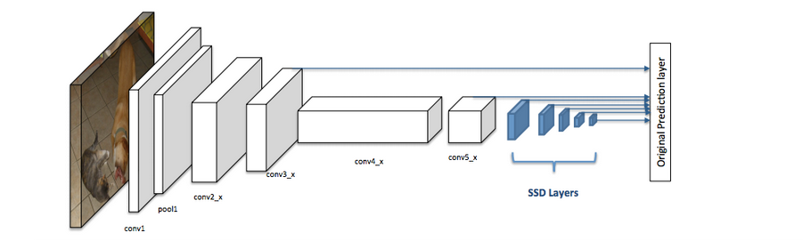

Fig 1 (SSD Layers)

* 1. Problem Statement

Detection of img details using ML model. img recognition is a field of computer vision that interprets imgs to aid decision making. img recognition is the final stage of img processing, which is the most important task of computer vision. So, how would you like to detect a moving object in a video?

Our objective is to capture the coordinates of the moving object and highlight the object in the video. Consider this frame from a video below:

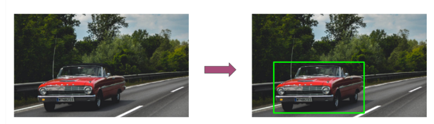

Fig 2 (Detection)

We would want our model to detect the moving object in a video as illustrated in the img above. The moving car is detected and a bounding box is created around the car.

Further we are also thinking of adding Theft detection using our model SYMBIOTE.

* 1. Objective of the work

The objective of our work is that we actually wanted to find out how object detection using SSD works and use its application to work in the theft detection models mainly in Vehicle Theft Detection.

* 1. Organization of the Project

A project organization is a structure that facilitates the coordination and implementation of project activities. The structure defines the relationships among members of the project management and the relationships with the external environment.

So, we have worked collectively to make our project a great success.

* 1. Summary

In this chapter we came to know about the actual objective and organization of our app SYMBIOTE: A Theft Detection model.

**CHAPTER-2  
RELATED WORK INVESTIGATION**

2.1 INTRODUCTION

***What is Object detection?***

Object detection is a computer vision approach for detecting things in photos and videos. To obtain relevant results, object detection algorithms often use machine learning or deep learning. We can recognise and locate objects of interest in photos or video in a handful of seconds when we glance at them. The purpose of object detection is to use a computer to imitate this intelligence.

***Why Does it Matter?***

Object detection is a crucial component of advanced driver assistance systems (ADAS), which allows cars to recognise driving lanes and pedestrians to improve road safety. Object detection is also useful in video surveillance and picture retrieval applications.

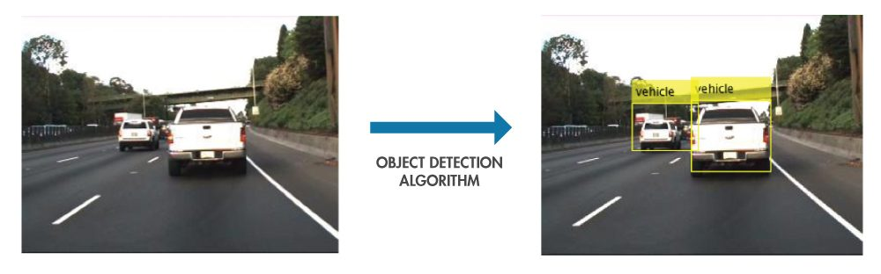

Fig 3 (Object Detection Algorithm)

***Where is object detection used?***

**Number plate identification** - recognising the alphanumeric characters on a vehicle utilizing both object detection and optical character recognition (OCR) technologies. Object detection can be used to take photos and detect cars inside them. The OCR technology converts the two-dimensional data into machine-encoded text once the model detects the number plate.

**Face detection and recognition** - as previously said, face detection and recognition is one of the most common applications of object detection. We can recognise human faces in a picture or video using contemporary algorithms. Due to one-shot learning algorithms, it is now possible to recognise faces with just a single training img.

**Object tracking** - when viewing a baseball or cricket game, the ball may hit a long distance away. It's important to keep track of the ball's motion as well as the distance it's traversing in these scenarios. Object tracking can help us do this by providing us with constant information on the ball's moving direction.

**Self-driving automobiles** - studying the various components around the car while driving is critical for autonomous cars. The ability of autonomous cars to recognise diverse entities requires an object detection model that has been trained on multiple classes.

**Robotics** - Robots perform a variety of duties such as lifting heavy objects, picking and placing items, and other real-time tasks. For robots to recognise items and automate jobs, object detection is required.

2.2 CORE AREA OF THE PROJECT

***WE ARE USING OBJECT DETECTION FOR THEFT DETECTION.***

***FOR OBJECT DETECTION WE ARE USING SSD ALGORITHM.***

1. We will use our Model for surveillance.
2. This surveillance system can be used for theft detection.
3. In this model we will be currently working on theft detection of cars.
4. In the future, We will be working on other things as well by increasing our dataset and training the model.

***What will we be using in our data set to find the car?***

1. img of the car
2. Number Plate
3. Color
4. Model of car
5. Year of Manufacturing
6. Any modifications done to the car.

***We will Explain our software’s purpose with example:***

1. Suppose there is a person Mr. X who has a car and another person Mr. Y who has stolen Mr. X's Car.
2. Mr X goes to the police to register a complaint against Mr. Y.
3. Now the police has 2 ways to find the car:
   1. To look upon the whole CCTV of the nearby areas and find the car.
   2. Else use our Symbiote to actually detect where the car actually is.
4. By using our software the police can save a lot of time and get the work to be done faster.
5. Only Mr. X needs to give details about his car and our software will detect where it has traveled in the whole city by CCTV footage.



Fig 4



Fig 5



Fig 6

2.3 EXISTING APPROACHES/METHODS

***Object Detection Algorithms -***

1. Histogram of Oriented Gradients (HOG)
2. Region-based Convolutional Neural Networks (R-CNN)
3. Faster Region-based Convolutional Neural Networks (Faster R-CNN)
4. Single Shot Detector (SSD) - (One we used in our project)
5. You Only Look Once (YOLO)

***Single Shot Detector (SSD) -***

**Introduction -** One of the fastest approaches to achieve real-time computation of object detection tasks is to use a single-shot detector for multi-box predictions. While the Faster R-CNN techniques can produce high prediction accuracies, the total process takes a long time and requires the real-time job to operate at around 7 frames per second, which is not ideal.

The single-shot detector (SSD) tackles this problem by increasing frame rates by nearly five times over the Faster R-CNN model. It does away with the area proposal network in favor of multi-scale features and default boxes.

**Architecture -** The architecture of a single-shot multibox detector can be broken down into three parts. The feature extraction stage of the single-shot detector is where all of the important feature maps are chosen. There are no other layers in this architectural region except completely convolutional layers. The process of finding heads begins when all of the essential feature maps have been extracted. Fully convolutional neural networks are also used at this step.

The task of the second stage of detection heads, on the other hand, is not to determine the semantic meaning of the imgs. Instead, the main purpose is to generate the best bounding maps for all of the feature maps. The final stage is to run it through the afterburner after we've computed the two critical stages.

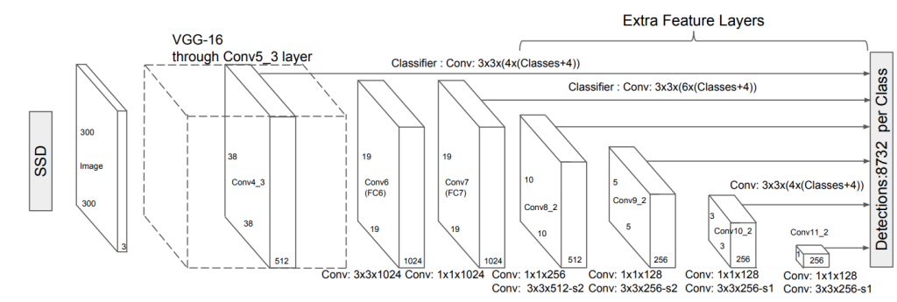

Fig 7 (SSD Stages)

2.4 PROS AND CONS OF THE STATED APPROACHES/METHODS

***Pros of the methods-***

1. The use of a solid-state drive (SSD) allows for more precise object recognition.
2. It's better for:
   1. video forensics
   2. legal investigations
   3. landmark searches

***Cons of the methods-***

1. While the SSD considerably improves performance, it does so at the expense of lowering img resolution to a poorer quality.
2. For small-scale objects, the SSD architecture will often perform worse than the Faster R-CNN.

2.5 ISSUES/OBSERVATIONS FROM INVESTIGATION

A single-shot detector (SSD) is a detector that detects only one signal at a time. It doesn't use a delegated region proposal network and predicts border boxes and classes from feature maps in a single run. SSD introduces modest convolutional filters to predict object classes and offsets to default border boxes to boost accuracy. To accommodate the variance in aspect ratios, separate filters for default boxes are used. Object detection using multi-scale feature maps.

SSD can be educated from beginning to end to improve accuracy. SSD is more accurate in terms of location, scale, and aspect ratio predictions. With the enhancements mentioned above, SSD may reduce the input img resolution to 300 x 300 pixels while maintaining comparable accuracy. The model can run at real-time speed and still be accurate by omitting the designated region suggestion and utilizing lower resolution photos.

2.6 SUMMARY

In this we came to know about how the img detecting algo was developed and how an SSD works. Then we came to know about what are the core areas where the project can be used i.e. protecting someone’s work, plagiarism and many more. We have also looked upon the different approaches with their pros and cons of the method and what we have observed from these particular approaches.

**Chapter-3  
REQUIREMENTS ARTIFACTS**

3.1 INTRODUCTION

A requirement describes a condition or capability to which a system must conform. A requirement is either derived directly from user needs or stated in a contract, standard, specification, or other formally imposed document.

In the Conditions Operation (RM) operation, you use vestiges and artifact types to define conditions and support and enhance the description of conditions.

For illustration, you can use features and use cases to describe the conditions, and also enhance the description by creating plates, wireframes, or storyboards.

Artifact is a general term for an object in a depository. Vestiges can be of colorful types, which have customizable attributes and data types.

While there's no dereliction artifact type called “demand,” you can produce one or use the dereliction artifact types that are in the sample design templates.

Numerous artifact types are included in the sample design templates, including these types

1. Requirements/Conditions
2. Use cases
3. Design documents
4. Business process diagrams
5. Use case diagrams

Artifact formats can be specific to individual artifact types or can be used for multiple types. For illustration, you might use the textbook format for a point or a use case specification or a custom artifact type. Still, the illustration format is generally used simply for creating plates.

You can produce and colonize vestiges that are grounded on several formats, including these:-

1. Text

Use this format to produce rich- textbook demand content that can contain textbook, imgs, and bedded vestiges. This format is useful for textbook- grounded vestiges types, similar as actor and use case specifications, stoner stories, features, business pretensions, and glossary terms.

1. Module

Use this format to produce a structured document that consists of vestiges in a module.

1. Diagram

Use this format to produce graphical vestiges similar as wireframes, business process plates, and use case plates.

3.2 HARDWARE AND SOFTWARE REQUIREMENTS

The very common requirements required for any project are the hardware and software requirements.

Talking about the hardware requirements include-

1. Monitor
2. Keyboard
3. Mouse
4. Operating System- Linux- Ubuntu 16.04 to 17.10 or Windows 7 to 10, with 2GB RAM (4GB preferable).
5. CPU and RAM.

There are a lot of different parts of any given piece of software that can be artifacts. The software requirements are very basic that a Python version (preferably 3.9, 3.8, and 3.7) must be installed.

3.3 SPECIFIC PROJECT REQUIREMENTS

3.3.1 *Data requirements:*

The data that we require for the projects are a set of 200 imgs that will be used for training and testing the model. We also have done a user interaction phase where we asked the user for the img and the model will identify the object.

3.3.2 *Function requirements:*

The basic functions and libraries used building our project our-

1. CV2: OpenCV-Python is a library of Python tapes designed to break computer vision problems. cv2. imread () system loads an img from the specified train. OpenCV is a great tool for img processing and performing computer vision tasks. It's an open- source library that can be used to perform tasks like face discovery, expostulation shadowing, corner discovery, and much further. It supports multiple languages including python, java, C++.
2. PIL from img: PIL is the Python Imaging Library which provides the python practitioner with img editing capabilities. The img module provides a class with the same name which is used to represent a PIL img. Public interest action is the use of the law to advance mortal rights and equivalency, or raise issues of broad public concern. It helps advance the cause of nonage or underprivileged groups or individualities. Public interest cases may arise from both public and private law matters.
3. OS: The OS module in Python provides functions for interacting with the operating system. The OS comes under Python's standard mileage modules. This module provides a movable way of using operating system-dependent functionality. In veritably simple terms, an operating system is software that manages the tackle coffers of the computer. Hence, it needs to run directly on top of the tackle without anything in between, this is called running bare essence.
4. Sys: The sys module in Python provides colorful functions and variables that are used to manipulate different corridors of the Python runtime terrain. It allows operating on the practitioner as it provides access to the variables and functions that interact explosively with the practitioner.
5. Tkinter provides Python users with a simple way to create GUI elements using the widgets found in the Tk toolkit. Tk widgets can be used to construct buttons, menus, data fields, etc.
6. NumPy: NumPy can be used to perform a wide variety of fine operations on arrays. It adds important data structures to Python that guarantee effective computations with arrays and matrices and it supplies an enormous library of high- position fine functions that operate on these arrays and matrices.
7. Tensor Flow: It is a free and open source software library for machine learning and artificial intelligence. It can be used across a range of tasks but has a particular focus on training and interface of deep neural networks.
8. Skimg: We can crop imgs inside your Python tablet as well using skimg. We crop imgs to remove the unwanted portion of the img or to concentrate on a particular part of the img. scikit- img is a collection of algorithms for img processing. It's available free of charge and free of restriction.
9. Matplotlib: Matplotlib is a conniving library for the Python programming language and its numerical mathematics extension NumPy. It provides an object-aware API for bedding plots into operations using general- purpose GUI toolkits like Tkinter, wxPython, Qt, or GTK.
10. Math: What's a math module in Python? The math module is a standard module in Python and is always available. To use fine functions under this module, you have to import the module using import math. It gives access to the underpinning C library functions.

3.4 SUMMARY

In this chapter, we learnt about the requirement artifacts, which enable us to know what all hardware and software are required upon the completion of our project. Then we came to know about what all are the python functions, libraries and modules required for the completion; what all dataset we require for its completion.

**CHAPTER:4  
DESIGN METHODOLOGY AND ITS NOVELTY**

* 1. METHODOLOGY AND GOAL

FOR THEFT DETECTION, WE ARE USING OBJECT DETECTION WITH SSD ALGORITHM FOR OBJECT DETECTION.

For surveillance, we'll employ our Model.

Theft detection is possible with this monitoring system.

We'll be working on car theft detection in this model right now.

We'll be working on other topics in the future, such as expanding our dataset and training the model.

What will we use to find the car in our data set?\

1. The car's img
2. Personalized License Plate
3. Color
4. Automobile model
5. Manufacturing Year
6. Any changes made to the vehicle.

***Steps for detecting the Car:***

1. Assume there is a person who owns a car and another person who has stolen that person’s vehicle.
2. He/She goes to the police station to file a report against that person.
3. The police now have two options for finding the automobile:
   1. Look through all of the CCTV in the area and find the car, or look through all of the CCTV in the area and find the car.
   2. Otherwise, use our Symbiote to find out where the automobile is.
4. The cops may save a lot of time and get their task done faster by using our software.
5. All that person has to do is provide information about his vehicle, and our software will use CCTV footage to determine where it has driven throughout the city.
6. Our model will be trained with the imgs that are taken from the frames of the CCTV footage and will spot the car defined by the person.
   1. SOFTWARE ARCHITECTURE DIAGRAM

The first goal architecture diagram -

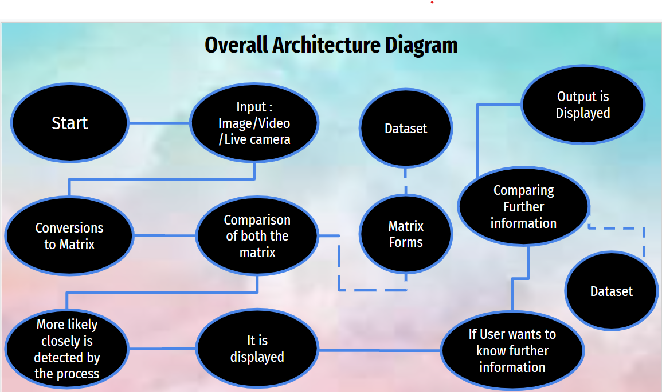

Fig 8

The second Architecture Diagram -

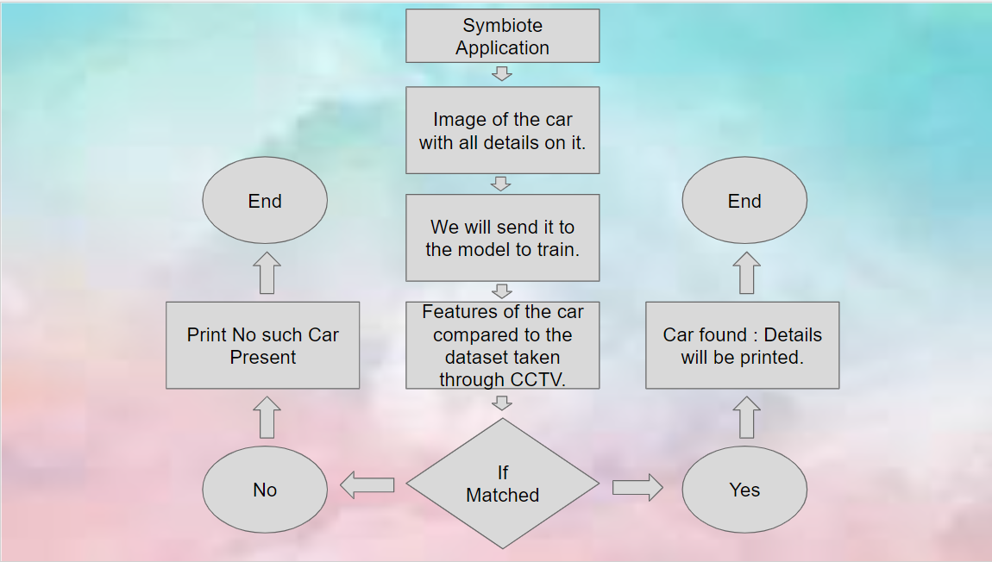

Fig 9

* 1. SUBSYSTEM SERVICES

The Services that will be provided with our application is:

1. Surveillance for theft detection or any other activities
2. Object detection
3. Automated driving
4. Identification of object in retail
5. Identification of animals in agriculture
6. Self driving cars
   1. NOVELTY OF THE PROJECT

There are tonnes of object detection projects out there but why our project stands out different is-

1. Our project is more user friendly
2. It provides more detail about an object Can be used for detecting a certain object in a huge folder of imgs
3. These applications makes it favorable for censoring certain objects in an imgs
4. Also helps in surveillance
5. User Friendly
6. Easy to Use
   1. SUMMARY

In this chapter we came to know about the proposed methodology and goals proposed by us. The functional module design analysis along with the structural architecture design with subsystem services provided.

**CHAPTER:5**

**TECHNICAL IMPLEMENTATION & ANALYSIS**

5.1 OUTLINE



Fig 10

5.2 TECHNICAL CODING AND CODE SOLUTIONS

1. The code for comparison of the dataset is as follows-

import functools

import json

import os

import tensorflow.compat.v1 as tf

from tensorflow.python.util.deprecation import deprecated

from object_detection.builders import dataset_builder

from object_detection.builders import graph_rewriter_builder

from object_detection.builders import model_builder

from object_detection.legacy import trainer

from object_detection.utils import config_util

tf.logging.set_verbosity(tf.logging.INFO)

flags = tf.app.flags

flags.DEFINE_string('master', '', 'Name of the TensorFlow master to use.')

flags.DEFINE_integer('task', 0, 'task id')

flags.DEFINE_integer('num_clones', 1, 'Number of clones to deploy per worker.')

flags.DEFINE_boolean('clone_on_cpu', False,

'Force clones to be deployed on CPU. Note that even if '

'set to False (allowing ops to run on gpu), some ops may '

'still be run on the CPU if they have no GPU kernel.')

flags.DEFINE_integer('worker_replicas', 1, 'Number of worker+trainer '

'replicas.')

flags.DEFINE_integer('ps_tasks', 0,

'Number of parameter server tasks. If None, does not use '

'a parameter server.')

flags.DEFINE_string('train_dir', '',

'Directory to save the checkpoints and training summaries.')

flags.DEFINE_string('pipeline_config_path', '',

'Path to a pipeline_pb2.TrainEvalPipelineConfig config '

'file. If provided, other configs are ignored')

flags.DEFINE_string('train_config_path', '',

'Path to a train_pb2.TrainConfig config file.')

flags.DEFINE_string('input_config_path', '',

'Path to an input_reader_pb2.InputReader config file.')

flags.DEFINE_string('model_config_path', '',

'Path to a model_pb2.DetectionModel config file.')

FLAGS = flags.FLAGS

@deprecated(None, 'Use object_detection/model_main.py.')

def main(_):

assert FLAGS.train_dir, '`train_dir` is missing.'

if FLAGS.task == 0: tf.gfile.MakeDirs(FLAGS.train_dir)

if FLAGS.pipeline_config_path:

configs = config_util.get_configs_from_pipeline_file(

FLAGS.pipeline_config_path)

if FLAGS.task == 0:

tf.gfile.Copy(FLAGS.pipeline_config_path,

os.path.join(FLAGS.train_dir, 'pipeline.config'),

overwrite=True)

else:

configs = config_util.get_configs_from_multiple_files(

model_config_path=FLAGS.model_config_path,

train_config_path=FLAGS.train_config_path,

train_input_config_path=FLAGS.input_config_path)

if FLAGS.task == 0:

for name, config in [('model.config', FLAGS.model_config_path),

('train.config', FLAGS.train_config_path),

('input.config', FLAGS.input_config_path)]:

tf.gfile.Copy(config, os.path.join(FLAGS.train_dir, name),

overwrite=True)

model_config = configs['model']

train_config = configs['train_config']

input_config = configs['train_input_config']

model_fn = functools.partial(

model_builder.build,

model_config=model_config,

is_training=True)

def get_next(config):

return dataset_builder.make_initializable_iterator(

dataset_builder.build(config)).get_next()

create_input_dict_fn = functools.partial(get_next, input_config)

env = json.loads(os.environ.get('TF_CONFIG', '{}'))

cluster_data = env.get('cluster', None)

cluster = tf.train.ClusterSpec(cluster_data) if cluster_data else None

task_data = env.get('task', None) or {'type': 'master', 'index': 0}

task_info = type('TaskSpec', (object,), task_data)

# Parameters for a single worker.

ps_tasks = 0

worker_replicas = 1

worker_job_name = 'lonely_worker'

task = 0

is_chief = True

master = ''

if cluster_data and 'worker' in cluster_data:

# Number of total worker replicas include "workers"and the "master".

worker_replicas = len(cluster_data['worker']) + 1

if cluster_data and 'ps' in cluster_data:

ps_tasks = len(cluster_data['ps'])

if worker_replicas > 1 and ps_tasks < 1:

raise ValueError('At least 1 ps task is needed for distributed training.')

if worker_replicas >= 1 and ps_tasks > 0:

# Set up distributed training.

server = tf.train.Server(tf.train.ClusterSpec(cluster), protocol='grpc',

job_name=task_info.type,

task_index=task_info.index)

if task_info.type == 'ps':

server.join()

return

worker_job_name = '%s/task:%d' % (task_info.type, task_info.index)

task = task_info.index

is_chief = (task_info.type == 'master')

master = server.target

graph_rewriter_fn = None

if 'graph_rewriter_config' in configs:

graph_rewriter_fn = graph_rewriter_builder.build(

configs['graph_rewriter_config'], is_training=True)

trainer.train(

create_input_dict_fn,

model_fn,

train_config,

master,

task,

FLAGS.num_clones,

worker_replicas,

FLAGS.clone_on_cpu,

ps_tasks,

worker_job_name,

is_chief,

FLAGS.train_dir,

graph_hook_fn=graph_rewriter_fn)

if __name__ == '__main__':

tf.app.run()

* Training Model_Dataset

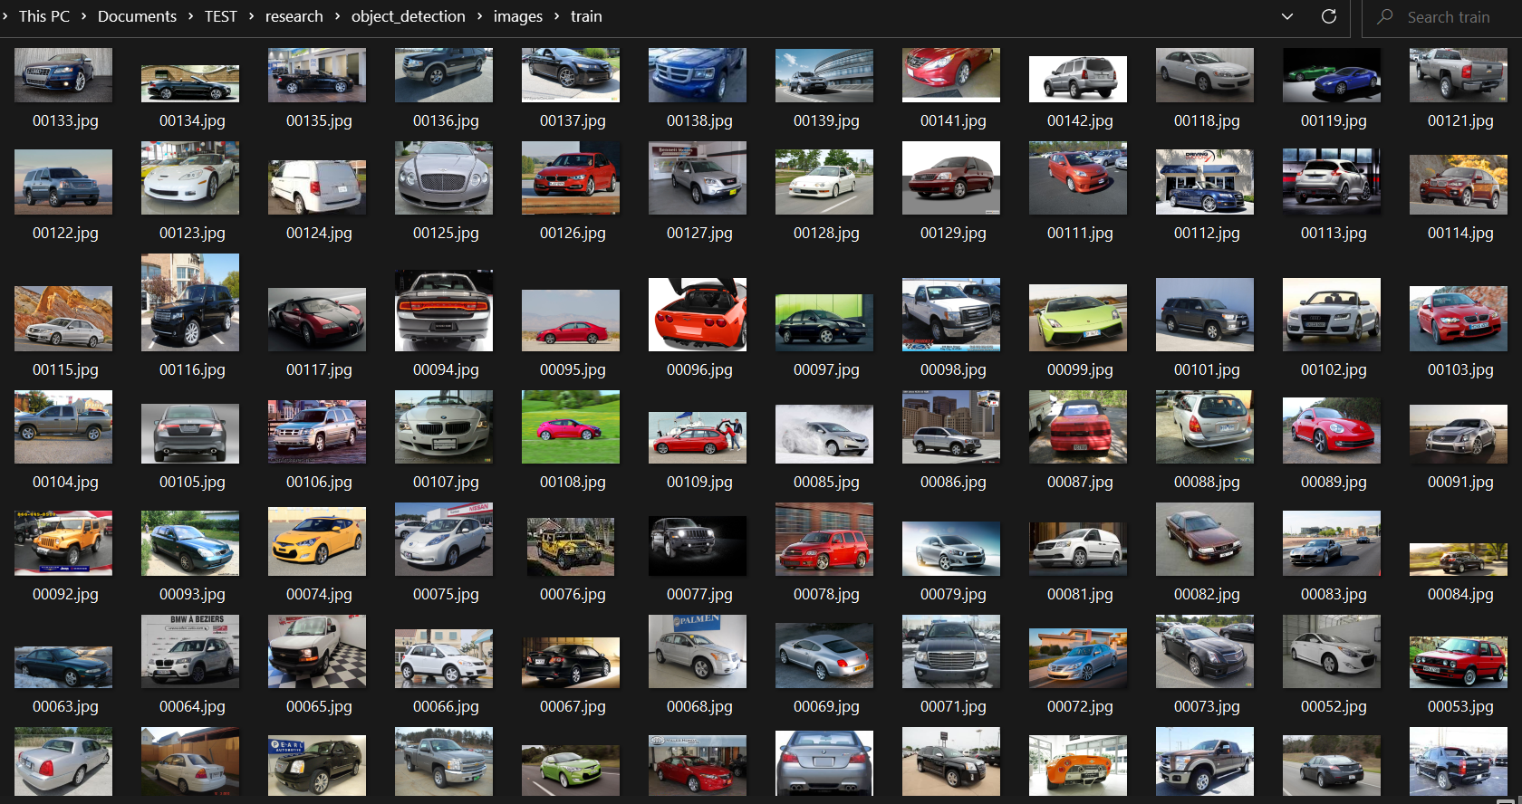

Fig 11

1. LabelImg

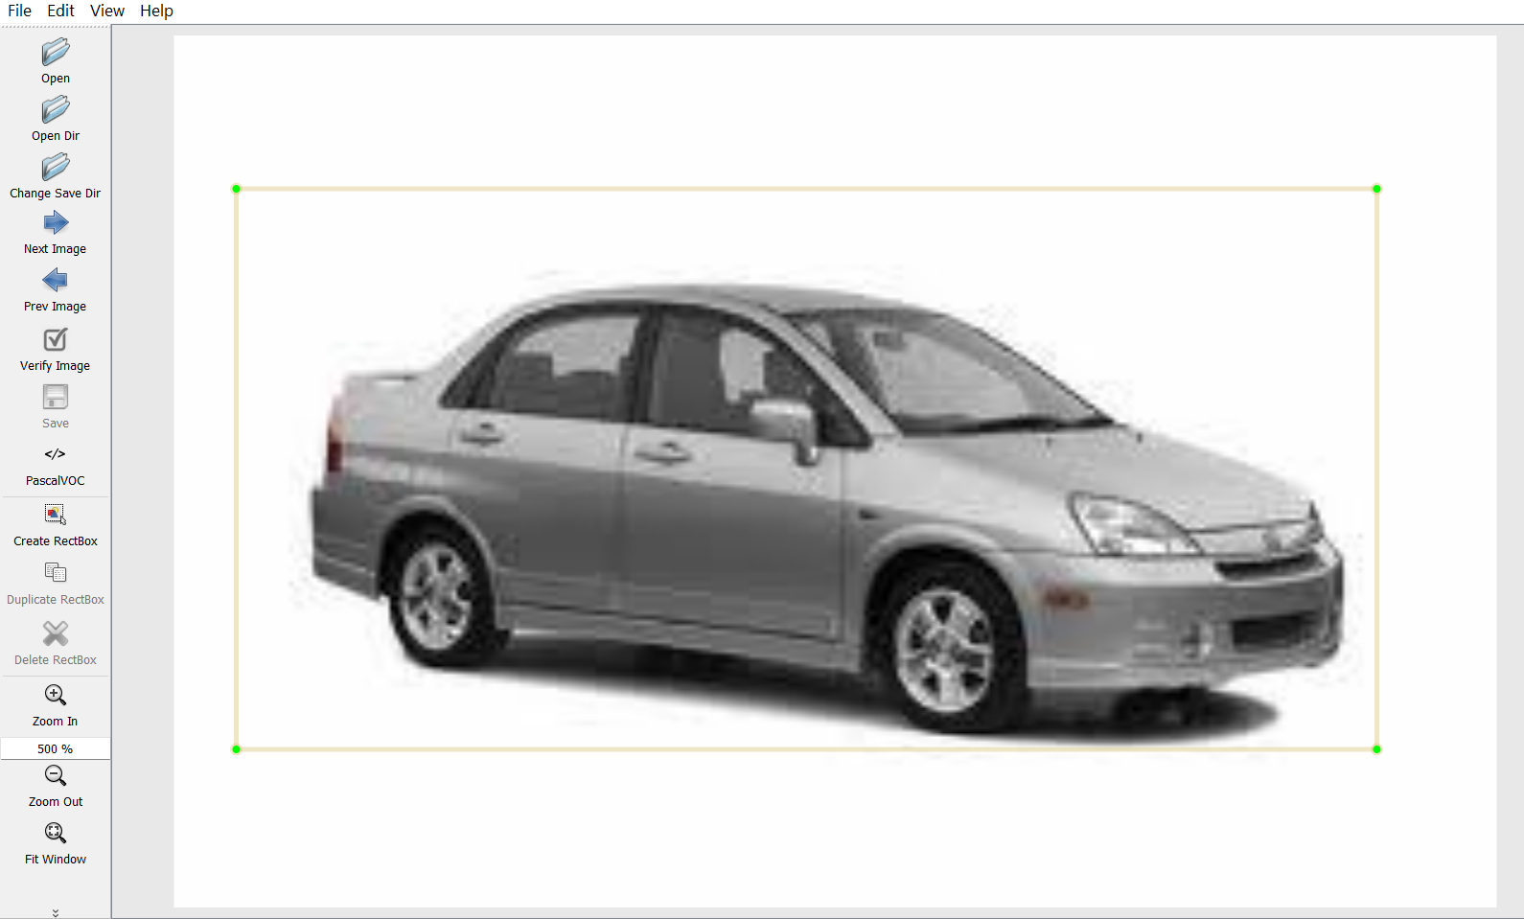

Fig 12

1. Training Model_Output

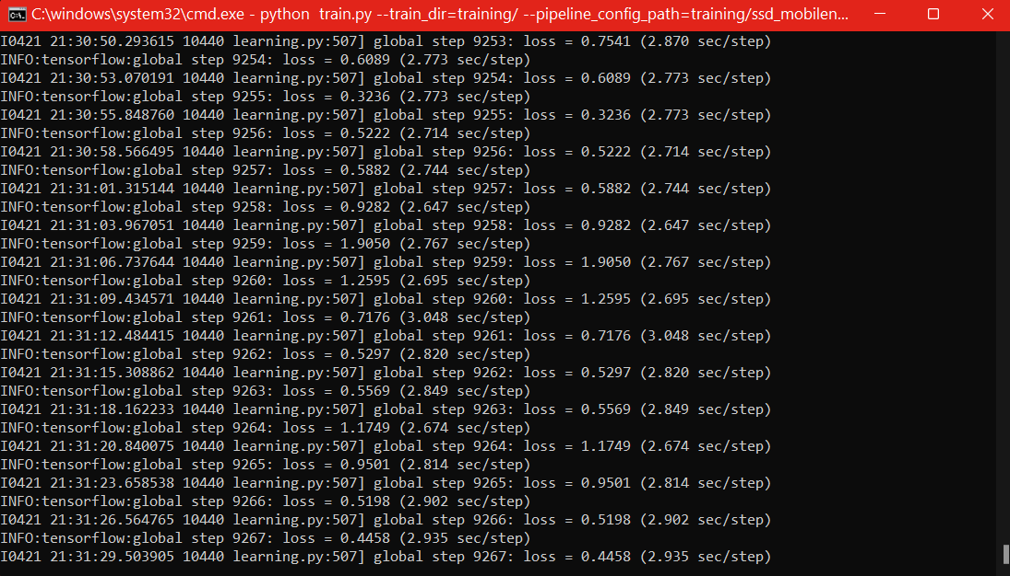

Fig 13

2. The set of code for the user interactive mode are-

import numpy as np

import os

import six.moves.urllib as urllib

import sys

import tarfile

import tensorflow as tf

import zipfile

import cv2

from collections import defaultdict

from io import StringIO

from matplotlib import pyplot as plt

from PIL import img

from IPython.display import display

from object_detection.utils import ops as utils_ops

from object_detection.utils import label_map_util

from object_detection.utils import visualization_utils as vis_util

# List of the strings that are used to add the correct label for each box.

PATH_TO_LABELS = '/content/models/research/object_detection/data/mscoco_label_map.pbtxt'

category_index = label_map_util.create_category_index_from_labelmap(PATH_TO_LABELS, use_display_name=True)

# If you want to test the code with your imgs, just add a path to the imgs to the TEST_img_PATHS.

PATH_TO_TEST_imgS_DIR = pathlib.Path('/content/')

TEST_img_PATHS = sorted(list(PATH_TO_TEST_imgS_DIR.glob("*.jpg")))

TEST_img_PATHS

model_name = 'ssd_mobilenet_v1_coco_2017_11_17'

detection_model = load_model(model_name)

print(detection_model.inputs)

detection_model.output_dtypes

def run_inference_for_single_img(model, img):

img = np.asarray(img)

# The input needs to be a tensor, convert it using `tf.convert_to_tensor`.

input_tensor = tf.convert_to_tensor(img)

# The model expects a batch of imgs, so add an axis with `tf.newaxis`.

input_tensor = input_tensor[tf.newaxis,...]

# Run inference

output_dict = model(input_tensor)

# All outputs are batch tensors.

# Convert to numpy arrays, and take index [0] to remove the batch dimension.

# We're only interested in the first num_detections.

num_detections = int(output_dict.pop('num_detections'))

output_dict = {key:value[0, :num_detections].numpy()

for key,value in output_dict.items()}

output_dict['num_detections'] = num_detections

# detection_classes should be ints.

output_dict['detection_classes'] = output_dict['detection_classes'].astype(np.int64)

# Handle models with masks:

if 'detection_masks' in output_dict:

# Reframe the bbox mask to the img size.

detection_masks_reframed = utils_ops.reframe_box_masks_to_img_masks(

output_dict['detection_masks'], output_dict['detection_boxes'],

img.shape[0], img.shape[1])

detection_masks_reframed = tf.cast(detection_masks_reframed > 0.5,

tf.uint8)

output_dict['detection_masks_reframed'] = detection_masks_reframed.numpy()

return output_dict

def show_inference(model, img_path):

# the array based representation of the img will be used later in order to prepare the

# result img with boxes and labels on it.

img_np = np.array(img.open(img_path))

# Actual detection.

output_dict = run_inference_for_single_img(model, img_np)

# Visualization of the results of a detection.

vis_util.visualize_boxes_and_labels_on_img_array(

img_np,

output_dict['detection_boxes'],

output_dict['detection_classes'],

output_dict['detection_scores'],

category_index,

instance_masks=output_dict.get('detection_masks_reframed', None),

use_normalized_coordinates=True,

line_thickness=9)

display(img.fromarray(img_np))

for img_path in TEST_img_PATHS:

show_inference(detection_model, img_path)

5.3 WORKING LAYOUT AND FORMATS; PROTOTYPE SUBMISSION:

1. The output of comparison of dataset-

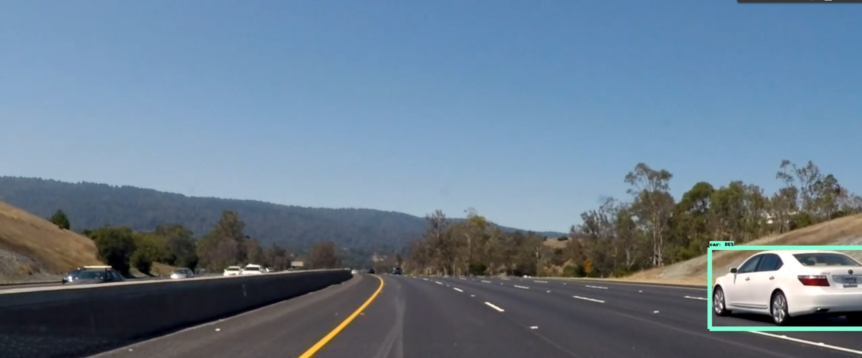

Fig 14

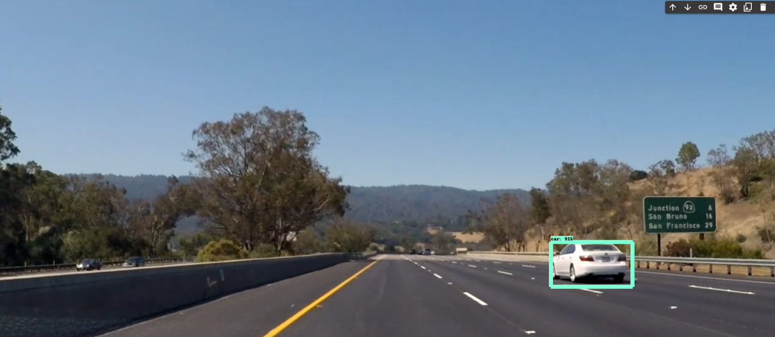

Fig 15

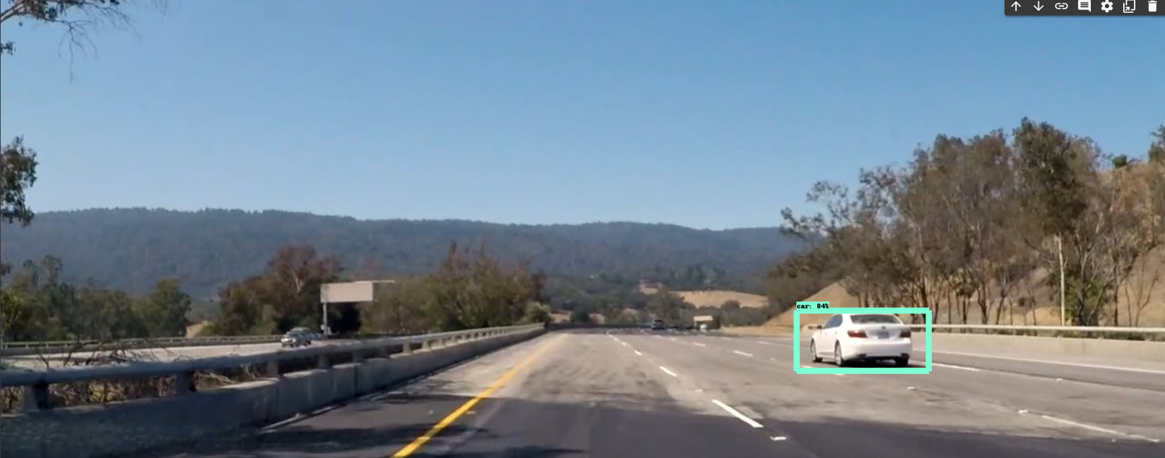

Fig 16

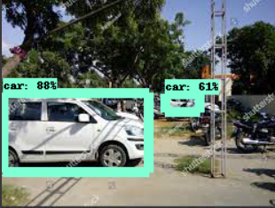

Fig 17

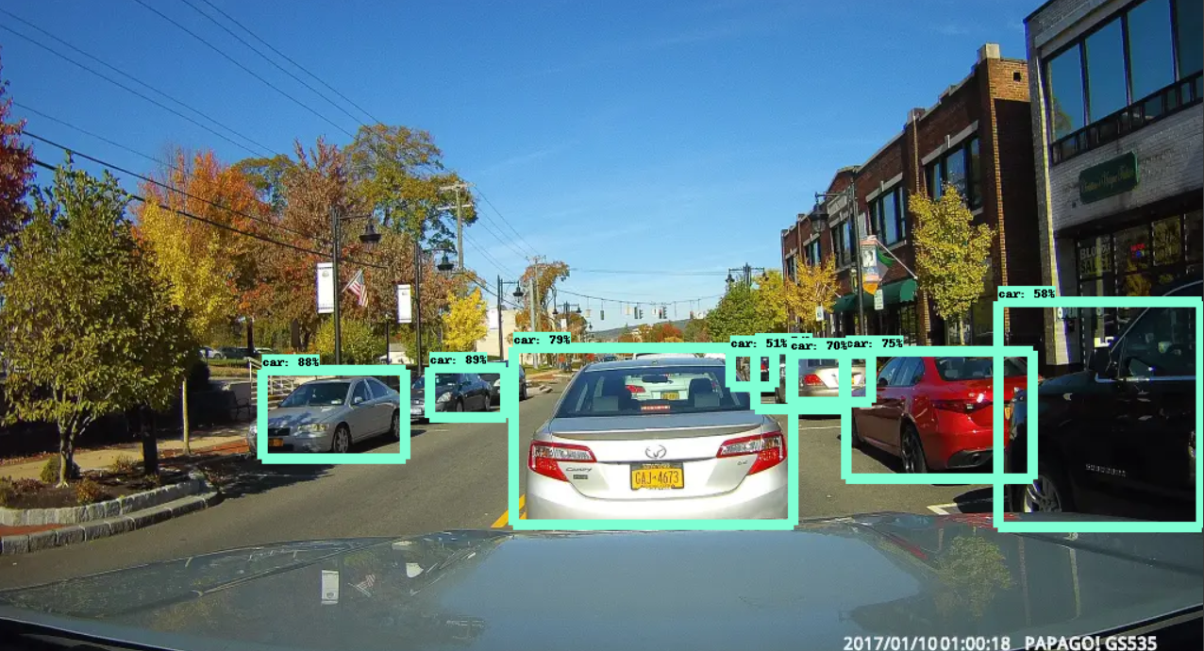

Fig 18

5.4 PERFORMANCE ANALYSIS

Performance Analysis is a specialized discipline that provides athletes and trainers with objective information that helps them understand performance. This process is sustained by methodical observation, which provides valid, dependable and detailed information relating to performance.

Hence, by using some different techniques we came to know that the performance of our application is really good.

5.5 SUMMARY

In this chapter we came to know about the outline, the working code and code solutions, the prototype submissions and the performance analysis of our application.

**CHAPTER:6**

**PROJECT OUTCOME AND APPLICABILITY**

6.1 OUTLINE

In this chapter, we will be talking about the positive approach of our project that we have tried to build upon. What are their key implementations, what is the significance of the project, its reliability in the real world?

6.2 KEY IMPLEMENTATIONS OUTLINES OF THE SYSTEM

Perpetration is the process that actually yields the smallest- position system rudiments in the system scale ( system breakdown structure). System rudiments are made, bought, or reused. Product involves the tackle fabrication processes of forming, removing, joining, and finishing, the software consummation processes of rendering and testing, or the functional procedures development processes for drivers' roles. However, a manufacturing system which uses the established specialized and operation processes may be needed, If perpetration involves a product process.

The purpose of the perpetration process is to design and produce (or fabricate) a system element conforming to that element’s design parcels and/ or conditions. The element is constructed employing applicable technologies and assiduity practices. This process bridges the system description processes and the integration process.

6.3 SIGNIFICANT PROJECT OUTCOMES

The significant project outcomes are -

1. Object Detection
2. Theft prevention and theft control
3. Surveillance
4. Object Tracking
5. Identification of objects

For example: Car - Company, Color, Number Plate, etc.

6.4 PROJECT APPLICABILITY ON REAL WORLD

The real world problem deals with the implementation of the many such events that may occur and will occur. Some of them are stated below:

* Theft Detection
* In malls can be of lost items

6.5 INFERENCE

In this chapter, we came to know about the real world examples of our project along with the significant outcomes.

**CHAPTER:7**

**CONCLUSIONS AND RECOMMENDATIONS**

7.1 OUTLINE

SYMBIOTE, is an application which has some cons too. As we know every coin has two faces likewise our application too has some pros and cons. So, in this chapter we will be talking about some of the limitations and constraints of our application and further will be discussing the future enhancements of the project.

7.2 LIMITATIONS/CONSTRAINTS OF THE SYSTEM

The limitation of our application may be-

* Mainly we are focusing upon how we how we can do theft detection, but it can be more easier if it can recognize the digits of a number plate, but right now it’s hard to actually implement how we can recognize the digits completely as sometime it's hard to actually see the imgs, due to some or other obstacles and sometimes the number plate isn’t that visible to us.
* One of the limitations can also be that sometimes it's hard to collect the CCTV footage from a certain area until it's not authorized properly. So, if we wanna do it on a small scale it’s hard to implement.

7.3 FUTURE ENHANCEMENTS

The future enhancements for our app may be that more features can be added to the system, and number plate recognition can be done to a certain level and more accurately.

7.4 INFERENCE

In this chapter, we learnt what are the limitations of our project and what all are the future enhancements of it.

# Appendix

## A.1 Interactive Mode

### A.1.1. *Error Handling*

When an error occurs, the interpreter prints an error message and a stack trace. In interactive mode, it then returns to the primary prompt; when input comes from a file, it exits with a nonzero exit status after printing the stack trace. (Exceptions handled by an except clause in a try statement are not errors in this context.) Some errors are unconditionally fatal and cause an exit with a nonzero exit; this applies to internal inconsistencies and some cases of running out of memory. All error messages are written to the standard error stream; normal output from executed commands is written to standard output.

Typing the interrupt character (usually Control-C or Delete) to the primary or secondary prompt cancels the input and returns to the primary prompt. [1](https://docs.python.org/3/tutorial/appendix.html#id2) Typing an interrupt while a command is executing raises the KeyboardInterrupt exception, which may be handled by a try statement.

### A.1.2. *Executable Python Scripts*

On BSD is Unix systems, Python scripts can be made directly executable, like shell scripts, by putting the line

*#!/usr/bin/env python3.5*

(assuming that the interpreter is on the user’s PATH) at the beginning of the script and giving the file an executable mode. The #! must be the first two characters of the file. On some platforms, this first line must end with a Unix-style line ending ('\n'), not a Windows ('\r\n') line ending. Note that the hash, or pound, character, '#', is used to start a comment in Python.

The script can be given an executable mode, or permission, using the **chmod** command.

**$** chmod +x myscript.py

On Windows systems, there is no notion of an “executable mode”. The Python installer automatically associates .py files with python.exe so that a double-click on a Python file will run it as a script. The extension can also be .pyw, in that case, the console window that normally appears is suppressed.

### A.1.3. The Interactive Startup File

When you use Python interactively, it is frequently handy to have some standard commands executed every time the interpreter is started. You can do this by setting an environment variable named PYTHONSTARTUP to the name of a file containing your start-up commands. This is similar to the .profile feature of the Unix shells.

This file is only read in interactive sessions, not when Python reads commands from a script, and not when /dev/tty is given as the explicit source of commands (which otherwise behaves like an interactive session). It is executed in the same namespace where interactive commands are executed, so that objects that it defines or imports can be used without qualification in the interactive session. You can also change the prompts sys.ps1 and sys.ps2 in this file.

If you want to read an additional start-up file from the current directory, you can program this in the global start-up file using code like if os.path.isfile('.pythonrc.py'): exec(open('.pythonrc.py').read()). If you want to use the startup file in a script, you must do this explicitly in the script:

**import** **os**

filename = os.environ.get('PYTHONSTARTUP')

**if** filename **and** os.path.isfile(filename):

**with** open(filename) **as** fobj:

startup_file = fobj.read()

exec(startup_file)

### A.1.4. *The Customization Modules*

Python provides two hooks to let you customize it: sitecustomize and usercustomize. To see how it works, you need first to find the location of your user site-packages directory. Start Python and run this code:

>>>

**>>> import** **site**

**>>>** site.getsitepackages()

'/home/user/.local/lib/python3.5/site-packages'

Now you can create a file named usercustomize.py in that directory and put anything you want in it. It will affect every invocation of Python, unless it is started with the [-s](https://docs.python.org/3/using/cmdline.html#cmdoption-s) option to disable the automatic import.

sitecustomize works in the same way, but is typically created by an administrator of the computer in the global site-packages directory, and is imported before usercustomize. See the documentation of the site module for more details.

**REFERENCES**